**Assignment 17.2:**

**Problem Statement 1**

1. Read the text file, and create a tuple rdd
2. Find the count of total number of rows present
3. what is the distinct number of subjects present in the entire school
4. what is the count of the number of students in the school, whose name is Matthew and mark is 55

**Reading the text file and creating a tuple RDD:**

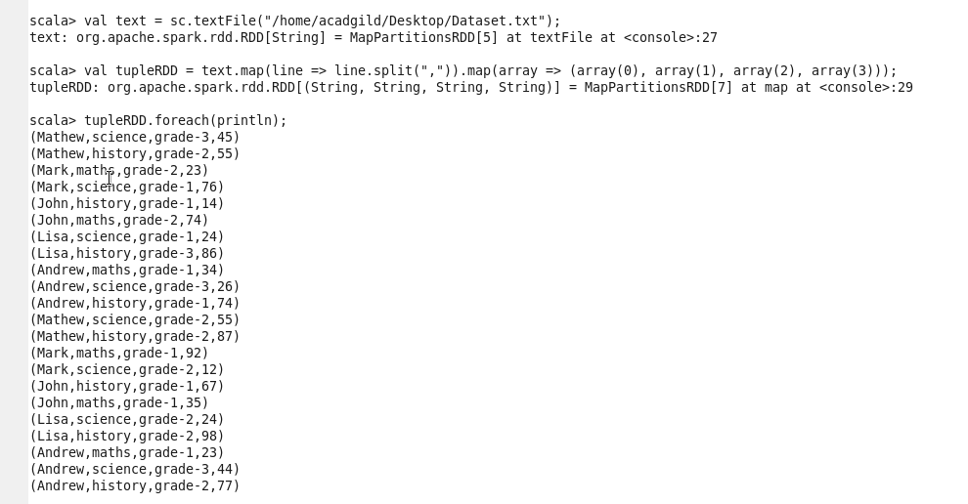

**Find the count of total number of rows present:**



**What is the distinct number of subjects present in the entire school:**



**What is the count the count of the number of students in the school, whose name is Matthew and mark is 55**

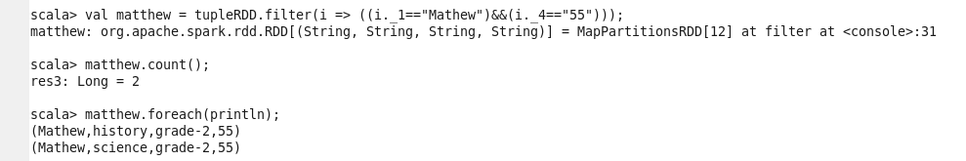

**Problem Statement 2**

1. What is the count of students per grade in the school?
2. Find the average of each student ( Note – Mathew is grade-1, is different from Mathew in some other grade!)
3. What is the average score of students in each subject across all grades?
4. What is the average score of students in each subject per grade?
5. For all students in grade-2, how many have average score greater than 50?

**What is the count of students per grade in the school?**

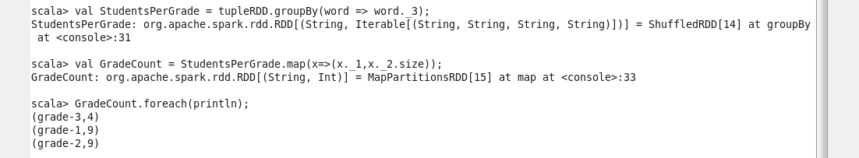

**Find the average of each student (Note – Mathew is grade-1, is different from Mathew in some other grade!)**



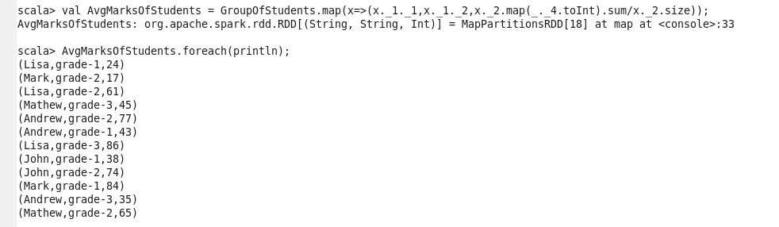

**What is the average score of students in each subject across all grades?**

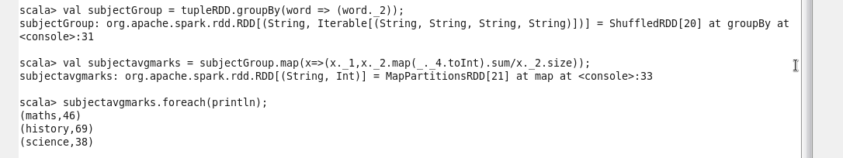

**What is the average score of students in each subject per grade?**

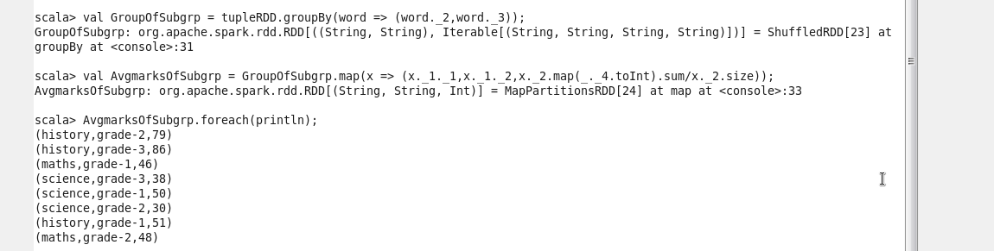

**For all students in grade-2, how many have average score greater than 50?**

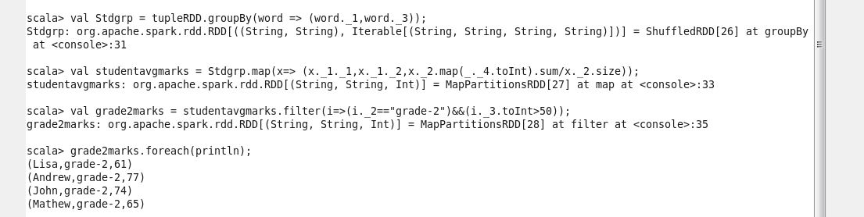

**Problem Statement 3**

Are there any students in the college that satisfy the below criteria:

1. Average score per student_name across all grades is same as average score per student_name per grade:

Hint: Use Intersection property

